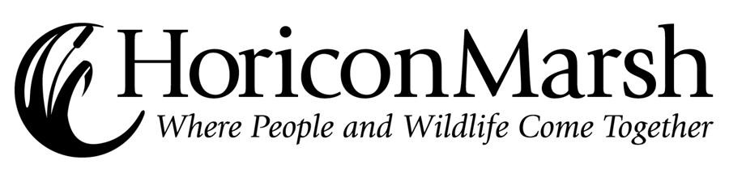
Fall 2009 Public Naturalist Programs

Date | Time | Program | Naturalist
Saturday  Sept. 19 | 10:00  1:00 | The Birds of Horicon  The Fall Migration | Bill Volkert
Sunday  Sept. 20 | 11:00  1:00 | Birding Basics  Mammals of Wisconsin | Liz Herzmann
Saturday  Sept. 26 | 10:00  1:00 | Birds and Bird Banding  Management & Ecology of Horicon Marsh | Bill Volkert
Sunday  Sept. 27 | 11:00  1:00 | Marsh Food Webs  A Horicon History | Liz Herzmann
Saturday  Oct. 3 | 10:00  1:00 | Horicon’s Indian History  Panel Discussion – Ancient Rock Art through Science, Art & Culture | Bill Volkert
Sunday  Oct. 4 | 11:00  1:00 | The Birds of Horicon  Managing Our Wildlife | Bill Volkert
Saturday  Oct. 10 | 10:00  1:00 | Fall Migration  The Geese of Horicon | Bill Volkert
Sunday  Oct. 11 | 11:00  1:00 | Horicon Marsh Habitat Hike  Fall Colors | Liz Herzmann
Saturday  Oct. 17 | 10:00  1:00 | The Birds of Horicon  Waterfowl Management | Bill Volkert
Sunday  Oct. 18 | 11:00  1:00 | Marsh Food Webs  Sharing Nature With Children | Liz Herzmann
Saturday  Oct. 24 | 10:00  1:00 | Muskrats, Mink and Other Marsh Mammals  The Geese of Horicon | Bill Volkert
Sunday  Oct. 25 | 11:00  1:00 | Horicon Marsh Habitat Hike  Mammals of Wisconsin | Liz Herzmann
Saturday  Oct. 31 | 10:00  1:00 | Managing Wisconsin’s Deer  Wisconsin Ice Age | Bill Volkert
Sunday  Nov. 1 | 11:00  1:00 | Birding Basics  Winter Adaptations | Liz Herzmann

