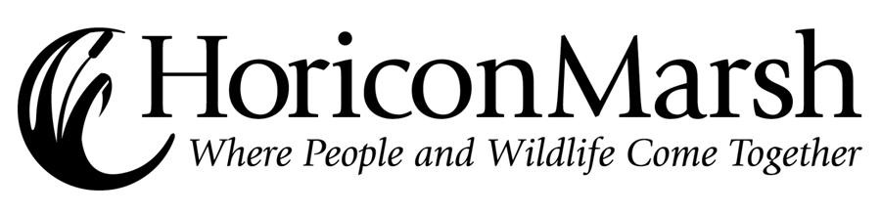

2009-2010 Public Lecture Series

Date | Program | Lecturer Name | Time
Wednesday  September 9 | Horicon Marsh Management Overview | Brenda Kelly | 7:00 P.M
Wednesday  September 23 | Reptiles and Amphibians of WI with Live Animals | Randy Hetzel | 7:00 P.M.
Wednesday  October 14 | Adventures with a Camera; Horicon’s Wildlife Close Up | Dr. Jack Bartholmai | 7:00 P.M.
Wednesday  October 28 | Kirtland’s Warblers in Wisconsin | Joel Trick | 7:00 P.M.
Wednesday  November 11 | Assessing Sandhill Crane Power Line Collision-risk in South-Central Wisconsin | Kimberly Ness | 7:00 P.M.
Wednesday  December 9 | Making the Connection, Environmental Protection and the Public Health | Pam Kober | 7:00 P.M.
Wednesday  January 13 | Duck Survival & Production in Wisconsin | Ron Gatti | 7:00 P.M.
Wednesday  January 27 | Water Quality Restoration for the Upper Rock River | Jim Congdon | 7:00 P.M.
Wednesday  February 10 | Star Gazing at the Marsh | Northern Cross Science Foundation | 7:00 P.M.
Wednesday  February 24 | Forest Management Practices | Randy Stampfl | 7:00 P.M.
Wednesday  March 10 | Furbearers of Forest and Wetland - Wisconsin's Amazingly Hairy Critters | John Olson | 7:00 P.M.
Wednesday  March 24 | Overview of Wetland Restoration and Management in Wisconsin | Ricky Lien | 7:00 P.M.
Wednesday  April 14 | Bird-scaping | Mariette Nowak | 7:00 P.M.
Wednesday  April 28 | Living with the Land;  Lessons in Natural Landscaping | Bill Volkert &  Connie Ramthun | 7:00 P.M.

